**PROJECT REPORT**

*Phase-I*

**On**

**AI Virtual Mouse Controller**

Submitted to Rajasthan Technical University

in partial fulfillment of the requirement for the award of the degree of

**B.TECH.**

**in**

**COMPUTER ENGINEERING**

**Submitted By**

**Sagar Gyanchandani – PIET18CS127**

**Rahul Chhablani – PIET18CS114**

**Yash Koolwal – PIET18CS153**

**Under the Guidance of**

**Mr. Deepak Moud**

at

**POORNIMA INSTITUTE OF ENGINEERING & TECHNOLOGY**

**JAIPUR**

**Rajasthan Technical University, KOTA**

**DECEMBER, 2021**

**CERTIFICATE**

This is to be certified that the project entitled “AI Virtual Mouse Controller” has been submitted for the Bachelor of Computer Science and Engineering, Poornima Institute of Engineering & Technology, Jaipur during the academic year 2021-2022 is a bonafide piece of project work carried out by “ Sagar Gyanchandani, Yash Koolwal & Rahul Chhablani” towards the partial fulfillment for the award of the Degree (B.Tech.) under the guidance of “Mr. Deepak Moud” and supervision and no part of thereof has been submitted by them for any degree or diploma.

Project Guide Project Coordinator Mr. Deepak Moud

Mr. Deepak Moud Prof. (Dr.) Rekha Jain HOD CSE

HOD CSE Professor

**CANDIDATE’S DECLARATION**

We, Sagar Gyanchandani **(PIET18CS127), Rahul Chhablani (PIET18CS114) & Yash Koolwal (PIET18CS153)** BTech (Semester- VII) of “**Poornima Institute of Engineering & Technology, Jaipur”** hereby declare that the Project Report entitled **“AI Virtual Mouse Controller”** is an original work and data provided in the study is authentic to the best of our knowledge. This report has not been submitted to any other Institute for the award of any other degree.

|  |  |  |
| --- | --- | --- |
| **Sagar Gyanchandani** | **Rahul Chhablani** | **Yash Koolwal** |
| **(PIET18CS127)** | **(PIET18CS114)** | **(PIET18CS153)** |

|  |  |
| --- | --- |
| **Place: Jaipur** |  |
| **Date: 10-05-22** |  |

**ACKNOWLEDGEMENT**It is our pleasure to be indebted to various people, who directly or indirectly contributed in the development of this work and who influenced our thinking, behavior and acts during the course of study.

We express our sincere gratitude to ***Dr. Dinesh Goyal,*** Director, ***PIET*** for providing us an opportunity to undergo this Major Project as the part of the curriculum.

We are thankful to ***Mr. Deepak Moud, HOD, CS*** for his support, cooperation, and motivation provided to us during the training for constant inspiration, presence and blessings.

We are thankful to ***Mr. Deepak Moud*** for his/her support, cooperation, and motivation provided to us during the training for constant inspiration, presence and blessings.

We also extend our sincere appreciation to***Prof. (Dr.) Rekha Jain*** who provided her valuable suggestions and precious time in accomplishing our Project report.

Lastly, we would like to thank the almighty and our parents for their moral support and friends with whom we shared our day-to-day experience and received lots of suggestions that improved our quality of work.

|  |  |  |
| --- | --- | --- |
| **Sagar Gyanchandani** | **Rahul Chhablani** | **Yash Koolwal** |
| **(PIET18CS127)** | **(PIET18CS114)** | **(PIET18CS153)** |

**TABLE OF CONTENTS**

|  |  |  |
| --- | --- | --- |
| **CHAPTER NO.** | **TOPICS** | **PAGE NO.** |
|  | TITLE PAGE | I |
|  | CERTIFICATE | II |
|  | CANDIDATE’S DECLARATION | III |
|  | ACKNOWLEDGEMENT | IV |
|  | ABSTRACT | VII |
| 1 | **INTRODUCTION** | 1 |
|  | Project Aim and Objective  Problem Statement  Software Requirements  Hardware Requirements |  |
| 2 | **LITERATURE SURVEY** | 3 |
| 3 | **PROJECT MANAGEMENT** | 6 |
|  | Project Integration Management   Project Scope Management   Project Time Management   Project Cost Management   Project Quality Management   Project Human Resource Management   Project Communication Management   Project Risk Management   Project Procurement Management   Project Management Tools |  |
| 4 | **TECHNOLOGY APPLIED** | 13 |
|  | Agile project management and Scrum  Core values of agile  Principles of agile  Steps in the agile methodology  POs and their relevance to project |  |
| 5 | **PRODUCT BACKLOG DESIGN** | 24 |
|  | Product Backlog  Sprint Backlog-1  Sprint Backlog-2  Sprint Backlog-3  Sprint Backlog-4 |  |
| 6 | **PROJECT IMPLEMENTATION** | 30 |
|  | Sprint Backlog-1  Sprint Backlog-2  Sprint Backlog-3  Sprint Backlog-4 |  |
| 7 | **RESULTS** | 34 |
|  | Outcome  Benefits to society  Future Scope |  |
|  | REFERENCES | 35 |
|  |  |  |
|  |  |  |
|  |  |  |

**ABSTRACT**

One of the most amazing Human-Computer Interaction (HCI) inventions is the mouse. Because it uses a battery for power and a dongle to connect it to the PC, a wireless mouse or a Bluetooth mouse still uses devices and is not completely device-free. This limitation can be overcome in the proposed AI virtual mouse system by using a webcam or a built-in camera to capture hand gestures and detect hand tips using computer vision. The system's algorithm is based on the machine learning algorithm. The computer can be controlled virtually using hand gestures and can perform left click, right click, drag and drop, and volume control functions without the use of a physical mouse. For detecting the hands, the algorithm uses deep learning. As a result, the proposed system will prevent COVID-19 from spreading by removing the need for human intervention and device control.

**KEYWORDS:**

OpenCV, Python, Mouse, Camera, Hand

**CHAPTER 1**

**INTRODUCTION**

**1.1 Introduction to Project**

With the advancement of technology in the areas of augmented reality and everyday devices, these devices are becoming more compact in the form of Bluetooth or wireless technologies. This paper presents an AI virtual mouse system that uses computer vision to perform mouse activities in the computer utilising hand motions and hand tip recognition. The suggested system's major goal is to execute computer mouse cursor and scroll tasks utilising a web camera or a computer's built-in camera instead of a standard mouse device. Computer vision is used to identify hand gestures and tip detection as an HCI with the computer. We can track the fingertip of a hand gesture using a built-in camera or web camera and execute mouse cursor operations and scrolling functions, as well as move the cursor using the AI virtual mouse system.

Some hardware, such as the mouse, the dongle to connect to the PC, and a battery to power the mouse to function, are utilised when using a wireless or Bluetooth mouse, but in this article, the user uses his or her built-in camera or webcam and uses hand gestures to control the computer mouse operations. The web camera in the suggested system records and processes the acquired frames, detects the various hand motions and hand tip gestures, and then performs the specific mouse operation.

The AI virtual mouse system was created using the Python programming language, as well as OpenCV, a computer vision library. The proposed AI virtual mouse system makes use of the MediaPipe package for tracking the hands and the tip of the hands, as well as the Pynput, Autopy, and PyAutoGUI packages for moving around the computer's window screen and performing functions like left click, right click, and scrolling functions. The proposed model's results demonstrated a very high level of accuracy, and the proposed model can function extremely well in real-world applications using only a CPU and no GPU.

**1.2 Project Aim and Objective:**

The suggested AI virtual mouse technology can be used to solve problems in the real world, such as instances where there isn't enough space to use a physical mouse or for people with hand problems who can't use a physical mouse. Furthermore, in the COVID-19 situation, it is not safe to use devices by touching them because this could result in the virus spreading, so the proposed AI virtual mouse can be used to overcome these issues because hand gesture and hand Tip detection is used to control the PC mouse functions by using a webcam or a built-in camera.

The suggested AI virtual mouse system's main goal is to create an alternative to the regular and traditional mouse system for performing and controlling mouse functions. This can be accomplished using a web camera that captures hand gestures and hand tips and then processes these frames to perform specific mouse functions like left click, right click, and scrolling.

**1.3 Problem Statement:**

The computer can be controlled virtually using hand gestures and can perform left click, right click, drag and drop, and volume control functions without the use of a physical mouse. For detecting the hands, the algorithm uses deep learning. As a result, the proposed system will prevent COVID-19 from spreading by removing the need for human intervention and device control.

**1.4 Software Requirements:** VsCode, OpenCV Python, Pycharm

**1.5 Hardware Requirements:** PC and Webcam

**CHAPTER 2**

**LITERATURE SURVEY**

Seven current research publications on vision-based hand gesture recognition are categorised here. This section provides an overview of the many architectural techniques used to create Hand gesture apps, with a focus on research direction, technology, and theoretical proofs or simulation findings.

The main goal of this study is to operate any Computer Vision algorithms-based application running on a computer using two of the most important modalities of interaction: the head and the hand. The video input stream is divided. Based on the shape and pattern of movement of the hand, the appropriate gesture is recognised. For the head gesture, a hidden Markov model is used. Hand and head gesture recognition commonly uses pre-processing. Capture a frame from the camera first. Second, the Viola J.

The main goal of static hand gesture identification is to classify given hand gesture data represented by specific attributes into a predetermined fixed number of gesture classes. The goal of this project is to investigate the usage of two feature extraction approaches, specifically hand contour and complex moments, to tackle the problem of hand gesture identification by identifying the key benefits and drawbacks of each method. The back-propagation learning algorithm is used to create an artificial.

The image of a hand motion is processed in three stages: pre-processing, feature extraction, and classification. Some operations are performed in the pre-processing stage to remove the hand gesture from its context and prepare the hand gesture image for feature extraction. The hand shape is employed as a factor in the very first procedure to deal with scaling and translation difficulties.

Five major steps make up the gesture recognition system. Input image acquisition, pre-processing, feature extraction, gesture classification, and creation of appropriate command for the system are the steps involved. Industrial robot control, sign language translation, and rehabilitation devices for those with upper extremity physical limitations could all benefit from vision-based hand gesture detection. In the pre-processing and feature extraction stages of the vision-based Gestural Controllab.

The SIFT and MBC algorithms are then employed in the feature extraction stages. An original signal is decomposed into three complementary components: direction, amplitude, and phase, using monogenic signal representation. After encoding the monogenic variation in each local region and monogenic feature in each pixel, the statistical characteristics of the extracted local features are calculated. Other local feature extraction approaches are much more time and space complex than the proposed MBC

The goal of a gesture recognition system is to establish a natural interface for humans to operate or communicate with a technological device. The goal of this project was to create a gesture-based control system for a robotic freight ramp. They chose a generic webcam for the image acquisition process, and they defined a gesture vocabulary for telerobotic control using a gesture recognition algorithm based on histograms and motion detection, making it suitable for real-time control, easy to implement, and efficient in unconstrained environments.

One of the most typical challenges faced when using a single camera is gesture recognition for motions made from side angles. A hand gesture detection system for numerous viewing angles utilising a single camera is given using a mix of Affine Transform and Discrete Fourier Transform (DFT). The system can effectively recognise movements produced from diverse angles, with an average recognition rate of 95.28 percent for gestures made at +-30 degrees and 90.30 percent for motions made at +-45 degrees, respectively, which is regarded good in the field of computer vision. By including DFT features, the suggested system becomes invariant under translation, rotation, and scaling.

In this technology, an affine transformation at a specific angle makes motions input from varied angles look almost identical to gestures produced on a 0 degree platform. As a result, the proposed method can be deemed an effective method for detecting multi-angle gestures. Because only a single camera is needed, the system appears to be simple to operate and cost effective, and the experimental findings indicate that the system's performance is adequate and that it can be used.

To make the interaction more efficient and dependable, a vision-based system is presented to control various mouse actions such as left and right clicking using hand gestures. This study describes a vision-based interface for controlling a computer mouse with two-dimensional hand motions. The camera-based colour detection technology is used to detect hand motions. This method primarily focuses on the cost-effective development of a virtual HCI device using a Web Camera. Each input image's centroid is located. Hand movement also moves the centroid, making it the sensing principle for changing the cursor on a computer screen. The hand image is used as the parent image in this case.

As a result, comparing the length of fingers in infant photographs to those in mother images provides insight about the functionality of the hand gesture. It performs a clicking action when the length of the finger crosses the threshold length in the baby image. Using red and blue coloured caps on the fingers to make the centroid look more apparent, the efficiency of tracking the hand is improved. After doing the research, the author feels that this technology has a bright future in HCI-based systems. It has numerous applications in robotics, biomedical instruments, computer gaming, and other industries.

**CHAPTER 3**

**PROJECT MANAGEMENT**

Project management has evolved from few simple principles to a wide subject with many complex concepts. To make it easier for people to understand project management, all PMBOK knowledge areas are classified into nine categories by PMBOK Guide. It is one of the most comprehensive model documents for project managers. In this article, we will take a deeper look at each of these knowledge areas to give you a better perspective of project management.

**1. Project Integration Management**

PMI defines project integration management as, “Processes and activities needed to identify, define, combine, unify and coordinate different processes and activities with project management process groups.” In short, project managers will have to keep an eye on every aspect of a project and check if everything is going according to the plan.

Good project integration is not possible without good teamwork. In order to be successful, you should have the resources who know their role and responsibilities. It is the responsibility of project managers to make project objectives clear and manage the inter-dependencies effectively to complete projects successfully. Therefore, project managers should focus on the bigger picture and follow a strategic approach to project management. Keep an eye on the obstacles and address them quickly before the problem gets out of hand.

**2. Project Scope Management**

Scope creep and lack of proper scope document is one of the main [reasons behind project failure](https://blog.taskque.com/causes-project-failure/). Furthermore, defining and documenting all the work comes under scope management. Project team should know what the deliverables are and what problems your project will solve. All this makes it easier for your team members to achieve the goals and helps clients in knowing what to expect from the projects. Therefore, project scope should also contain [milestones related to projects](https://blog.taskque.com/project-milestones-achieve/).

There are five sub-processes involved in the project scope management process.

* Collect requirements (Document stakeholder requirements)
* Define scope (Detailed description of project and what it will do)
* Create work breakdown structure (Dividing projects into smaller tasks)
* Verify scope (Getting acceptance of project deliverables from stakeholders)
* Control scope (Difference between actual and approved scope)

**3. Project Time Management**

One of the biggest challenges for project managers is to complete projects on time. However, most project managers do not understand this knowledge area. Hence, most projects under their supervision fail to complete before the deadline. There are six sub-processes associated with the project time management knowledge area that every project manager should know in order to complete projects on time.

Here are the six sub-processes:

* Define activities
* Sequence activities
* Estimate the resources required
* Estimate the time required
* Develop a schedule
* Control schedule

**4. Project Cost Management**

Most project managers consider managing costs against their project as their biggest challenge. However, cost management can be a difference maker between a successful project and a project failure. Many projects are abandoned due to budget constraints. If you do not want this to happen to your projects, then you should learn the art of effective project cost management and complete projects within the specified budgets. Latest tools and techniques can help you in this regard.

Here are three main sub-processes involved in project cost management.

* Estimate costs
* Determine budget
* Control costs

Make sure that you keep an eye on budget and expenditures so that you do not end up exceeding the budget. Unfortunately, most project managers do not pay attention to cost management from the beginning, spends a major chunk initially without any record and struggles to keep the project inside the budget later on. To keep project costs in check, you should track every dollar and where it is spent.

**5. Project Quality Management**

No matter how you define quality, a high-quality project is one which satisfies the customer needs and does not contain any defects and deficiencies. In order to achieve the highest project quality, project managers and their team should focus on customer requirements they have gathered initially, try to know what the customer wants and which problems your project will solve.

Develop a prototype of the project and give it to the end user to use it. Their feedback will allow you to make necessary adjustments before you deliver the final product to the customer. At the end of it all, the project should completely align with the user requirements in order to be called a high-quality project. Hence, all the requirements should be well documented so that your team can deliver a project that satisfies customer’s requirement.

**6. Project Human Resource Management**

Another knowledge area of project management that usually is ignored is project human resource management. It is the set of processes and activities involved in organizing, leading and managing project teams. It is how you manage the most valuable asset of your company i.e. people. To be successful at it, project managers should have a clear strategy when it comes to hiring and staffing people and inducting them into project teams. Hiring the right people can increase the chances of your success.

Project Human Resource Management process involves following sub-processes:

* Developing a human resource plan
* Hire the project team
* Develop a project team
* Manage project team

**7. Project Communication Management**

Poor project communications can wreck havoc on your project progress. Moreover, it can take your project towards failure. So, if you want to complete projects successfully, all team members should be on the same page. Moreover, they should work as a team to achieve the common objective. If you want that to happen, then you will have to communicate effectively and regularly. Project managers can enhance collaboration and communication among their team members by using [task management software](https://taskque.com/) that offers communications and collaboration features. Here are some of the key activities that project managers need to undertake to ensure uninterrupted communications throughout the project:

* Identify stakeholders
* Plan communications
* Distribute information
* Manage stakeholder expectations
* Report performance

**8. Project Risk Management**

Most project managers consider risk management as the most important factor in completing projects successfully. Therefore, effective risk management plays an important role in preventing your projects from failure. In addition to this, project managers can reduce the risk by following a proactive approach and managing risks at the initial stage. Project managers who ignore minor risks have to suffer from project failure because these minor risks can turn into major risk and can lead to a project disaster if left unattended. Here are some of the activities that project managers will have to undertake in project risk management:

* Plan risk management
* Identify risks
* Perform qualitative and quantitative risk analysis
* Plan risk response
* Monitor and control risks

**9. Project Procurement Management**

The Project Procurement Management knowledge area covers all the aspects related to purchase and acquiring of products and services needed to complete projects effectively. Although, the procurement process is quite transparent and conducted through a contract or agreement, it important for project managers to ensure that there are no discrepancies. Whether you are a buyer or seller, you need to understand both perspectives to get a better knowledge of the project procurement process. Additionally, cost benefit analysis, cost utility analysis, and risk analysis also comes under project procurement management.

* Plan procurement
* Conduct procurement
* Administer procurement
* Close procurement

**Project Management Tools:**

Project management required tools to manage the work , time and resources. At present many of the software are available for project management. Some of the popular software tools are as follows.

### 01. [Trello](http://send.getapp.com/aff_c?offer_id=677&aff_id=1371)

Trello is an project management tool, instead this app is a free visual way to to glance at the entire project with a single view. With Trello you can organise cards, these cards can be your thoughts, conversations and to-do lists and be placed on a board for everyone to collaborate on.

### 02. [Basecamp](http://send.getapp.com/aff_c?offer_id=637&aff_id=1371)

Basecamp is the granddaddy of project management apps. Basecamp is considered the leading project management tool around. It boost a simple and easy to use interface to collaborate with your team and client. It allows you to create multiple projects and setup discussions, write to-do lists, manage files, create and share documents, and organise dates for scheduling.

### 03. [Teamwork Projects](http://send.getapp.com/aff_c?offer_id=947&aff_id=1371)

Teamwork Projects is the ultimate productivity tool to manage projects with your team. Teamwork allows you to keep all your projects, tasks and files all in one place and easily collaborate with a team. Teamwork helps you to visualise the entire project through a marked calendar and gantt chart and setup reporting. Teamwork supports file management with Google Drive, Box.com and Dropbox. As well as integration with leading apps such as third party accounting software and customer support apps.

### 04. [Resource Guru](https://resourceguruapp.com/)

Billed as the "simple way to schedule people, equipment and other resources", Resource Guru is a streamlined resource scheduling and leave management tool that’s designed to keep your projects on track. You can plan your team's workloads, receive daily booking reminders, report on KPIs, and more. Apple, Saatchi & Saatchi and Deloitte are among some of the cloud-based team calendar’s heavyweight customers.

### 05. [ActiveCollab](http://send.getapp.com/aff_c?offer_id=949&aff_id=1371)

ActiveCollab recently released its new version 5.0. The new revamped app is now more powerful and focused project management tool. It offers team collaborating features, task management, time tracking and importing expenses. One of the biggest asset of ActiveCollab is it offers invoicing features. You are able to track payments and expenses and have invoices paid directly within ActiveCollab with PayPal, and other credit card payments.

### 06. [Zoho Projects](http://send.appdoubler.com/aff_c?offer_id=101&aff_id=1371)

Zoho offers a wide range of business software including Projects. Zoho Projects is an proficient tool to project plan and project coordinator from start to finish. It boost all the features you need for project management with some advance features including reporting, integration with Google Apps and Dropbox, bug tracking, setup Wiki Pages to build a repository of information, forums and more.

### 07. [Jira](http://send.getapp.com/aff_c?offer_id=281&aff_id=1371)

Jira is specifically targeted for software development teams. Jira offers abilities to raise issues and bugs. Jira makes it real easy to track bugs and see which issues are still outstanding and how much time was spent on each task. Jira offer other products including Confluence a document collaboration tool, and HipChat a team chat and video and file sharing platform and other products.

### 08. [Asana](http://send.getapp.com/aff_c?offer_id=587&aff_id=1371)

Asana is the easiest way for teams to track their work so everyone knows who's doing what, by when. With tasks, projects, conversations and dashboards, Asana keeps your work organized, and teammates accountable so you can move work forward faster. Asana also lets you keep track of your work wherever you are with mobile apps for both iOS and Android.

### 09. [Podio](http://send.getapp.com/aff_c?offer_id=951&aff_id=1371)

Podio is a ever growing tool to organise and communication tool for any business. Podio allows you to personalise this platform to fit your business needs. Besides being able to communicate with a team, setup task management, use as a file storage system, like a traditional project management app, Podio can be an internal intranet for all your colleagues and departments to interact.

### 10. [Freedcamp](https://freedcamp.com/)

Whatever your project may be, either setting up an event, a web project or organising a wedding, Freedcamp helps you organise and plan effectively. Freedcamp has an organised dashboard to view the entire project at a glance. You can easily setup tasks, use sticky notes to visually setup tasks and organise them into the calendar. Freedcamp provides advance add-ons for high level business use including CRM, invoicing, issue tracking and setting up wiki pages.

### 11. [Wrike](http://send.getapp.com/aff_c?offer_id=239&aff_id=1371)

Wrike is advance application to help you work smarter. By making sure you are always staying on track and ensure you have the adequate resources to finish on time and on budget.Setting up tasks, engage your team and integrate with your business tools including Google Apps, Microsoft Excel, Dropbox and many more is so easy with Wrike.

**CHAPTER 4**

**TECHNOLOGY APPLIED**

**Technologies applied in the Project:**

Python:

Python is a high-level, general-purpose programming language that is interpreted.

Its design philosophy emphasises code readability through extensive indentation.

Its language components and object-oriented strategy are intended to assist programmers in writing concise, reasonable code for both large and small applications.

OpenCV:

OpenCV is a programming library that focuses on real-time computer vision.

It's great for computer vision applications like video and CCTV footage analysis, as well as image analysis.

We can use this library to focus on real-world problems when developing computer vision applications that we don't want to build from scratch.

**Agile Methodology:**

Agile is one form of [software development methodology](http://manasbhardwaj.net/a-beginners-guide-to-various-software-development-methodologies/). Its main focus is on client satisfaction through continuous delivery. The focus of Agile is more on limiting the project scope. An agile project sets a minimum number of requirements and turns them into a deliverable product.

Agile development methodology provides opportunities to assess the direction of a project throughout the development lifecycle. By focusing on the repetition of abbreviated work cycles as well as the functional product they yield, agile methodology is described as “iterative” and “incremental”. In waterfall, development teams only have one chance to get each aspect of a project right. Various key terms associated with it are as follows-

**Scrum:** Scrum is a process framework used to manage product development and other knowledge work.  Scrum is empirical in that it provides a means for teams to establish a hypothesis of how they think something works, try it out, reflect on the experience, and make the appropriate adjustments.  That is, when the framework is used properly.  
Scrum is structured in a way that allows teams to incorporate practices from other frameworks where they make sense for the team’s context.

**Scrum master**: The scrum master is the team role responsible for ensuring the team lives agile values and principles and follows the processes and practices that the team agreed they would use.

The responsibilities of this role include:

* Clearing obstacles
* Establishing an environment where the team can be effective
* Addressing team dynamics
* Ensuring a good relationship between the team and [product owner](https://www.agilealliance.org/glossary/product-owner/) as well as others outside the team
* Protecting the team from outside interruptions and distractions.

The scrum master role was created as part of the Scrum framework.  The name was initially intended to indicate someone who is an expert at [Scrum](https://www.agilealliance.org/glossary/scrum/)and can therefore coach others.

The role does not generally have any actual authority. People filling this role have to lead from a position of influence, often taking a servant-leadership stance.

**Product Owner:** The product owner is a role on a product development team responsible for managing the product backlog in order to achieve the desired outcome that a product development team seeks to accomplish.  Key activities to accomplish this include:

* Clearly identify and describe product backlog items in order to build a shared understanding of the problem and solution with the product development team
* Make decisions regarding the priority of product backlog items in order to deliver maximum outcome with minimum output
* Determine whether a product backlog item was satisfactorily delivered
* Ensure transparency into the upcoming work of the product development team.

The product owner role was created as part of the Scrum framework in order to address challenges that product development teams had with multiple, conflicting direction, or no direction at all with respect to what to build.

Many infer that a product owner is someone who can spend a considerable amount of time with the product development team providing clarification on product backlog items, and making decisions about which product backlog items to do and regarding the specifics of those particular product backlog items.

**Product Backlog:** A product backlog is a list of the new features, changes to existing features, bug fixes, infrastructure changes or other activities that a team may deliver in order to achieve a specific outcome.

The product backlog is the single authoritative source for things that a team works on. That means that nothing gets done that isn’t on the product backlog. Conversely, the presence of a product backlog item on a product backlog does not guarantee that it will be delivered. It represents an option the team has for delivering a specific outcome rather than a commitment.

It should be cheap and fast to add a product backlog item to the product backlog, and it should be equally as easy to remove a product backlog item that does not result in direct progress to achieving the desired outcome or enable progress toward the outcome.

Product backlog items take a variety of formats, with [user stories](https://www.agilealliance.org/glossary/user-stories/) being the most common. The team using the product backlog determines the format they chose to use and look to the backlog items as reminders of the aspects of a solution they may work on.

Product backlog items vary in size and extent of detail based in large part in how soon a team will work on them. Those that a team will work on soon should be small in size and contain sufficient detail for the team to start work. The team may establish a [definition of ready](https://www.agilealliance.org/glossary/definition-of-ready/) to indicate their agreement on the information they’d like to have available in order to start working on a product backlog item. Product backlog items that are not slated for work may be fairly broad and have little detail.

The sequence of product backlog items on a product backlog changes as a team gains a better understanding of the outcome and the identified solution. This reordering of existing product backlog items, the ongoing addition and removal of product backlog items, and the continuous refinement of product backlog items gives a product backlog its dynamic characteristic.

A team owns its product backlog and may have a specific role – [product owner](https://www.agilealliance.org/glossary/product-owner/) – with the primary responsibility for maintaining the product backlog. The key activities in maintaining the product backlog include prioritizing product backlog items, deciding which product backlog items should be removed from the product backlog, and facilitating [product backlog refinement](https://www.agilealliance.org/glossary/backlog-grooming/).

A product backlog can be an effective way for a team to communicate what they are working on and what they plan to work on next. [Story Maps](https://www.agilealliance.org/glossary/storymap/) and [information radiators](https://www.agilealliance.org/glossary/information-radiators/) can provide a clear picture of your backlog for the team and stakeholders.

The product backlog can be represented in physical form using index cards or sticky notes, or or it may be represented in electronic form such as a text file, spreadsheet, or one of the many backlog management tools that exist. Electronic boards are the better option for a team that has remote members or collects a great deal of supplementary information about product backlog items. Physical boards offer the advantage of making the product backlog continuously visible and concrete during discussions around the product backlog.

**Sprint Backlog**: A sprint backlog is the subset of [product backlog](https://www.agilealliance.org/glossary/backlog/) that a team targets to deliver during a sprint in order to accomplish the sprint goal and make progress toward a desired outcome.

The sprint backlog consists of product backlog items that the team agreed with their [product owner](https://www.agilealliance.org/glossary/product-owner/) to include during [sprint planning](https://www.agilealliance.org/glossary/sprint-planning/). The team owns the sprint backlog and can determine whether new items are added or existing items are removed. This allows the team to focus on a clear scope for the length of the sprint. Some teams may allow the inclusion of a new product backlog item if it replaces a product backlog item of equal or greater size that already exists on the sprint backlog.

If a team identifies tasks needed to deliver the select product backlog item, those tasks also become part of the sprint backlog. The team can add or remove tasks to the sprint backlog throughout the course of the sprint. The sprint backlog also includes any action items the team identified from the previous retrospective meeting.

The sprint backlog is generally tracked on an information radiator to provide a visual signal of the progress of the team as well as indicate the scope of the current sprint. If the team does not identify tasks, the product backlog items are tracked through different stages of the workflow in a format sometimes referred to as a [delivery board](https://www.kbp.media/delivery-board/). If the team breaks their product backlog items into tasks, they will often use a [task board](https://www.agilealliance.org/glossary/taskboard/) to track those tasks.

The majority of product backlog items included on a sprint backlog are [user stories](https://www.agilealliance.org/glossary/user-stories/) that are appropriately described according to the team’s definition of ready. Other product backlog items could represent bugs that need to be addressed, research that needs to be done (typically in the form of spikes), or changes needed to the products architecture or infrastructure.

The sprint backlog only lasts for the duration of a sprint. Each new sprint starts with a new sprint backlog, although the team may choose to add items from the previous sprint’s sprint backlog to the new sprint backlog it those items contribute to completing the new sprint’s sprint goal.

**User story:** In consultation with the customer or [product owner](https://www.agilealliance.org/glossary/product-owner/), the team divides up the work to be done into functional increments called “user stories.”

Each user story is expected to yield, once implemented, a contribution to the value of the overall product, irrespective of the order of implementation; these and other assumptions as to the nature of user stories are captured by the [INVEST](http://guide.agilealliance.org/guide/invest.html) formula.

To make these assumptions tangible, user stories are reified into a physical form: an index card or sticky note, on which a brief descriptive sentence is written to serve as a reminder of its value. This emphasizes the “atomic” nature of user stories and encourages [direct physical manipulation](http://en.wikipedia.org/wiki/Direct_manipulation_interface): for instance, decisions about scheduling are made by physically moving around these “story cards”.

**Daily Meeting:** Each day at the same time, the team meets so as to bring everyone up to date on the information that is vital for coordination: each team members briefly describes any “completed” contributions and any obstacles that stand in their way. Usually, Scrum’s [Three Questions](https://www.agilealliance.org/glossary/three-qs/) are used to structure discussion. The meeting is normally held in front of the [task board](https://www.agilealliance.org/glossary/taskboard/).

This meeting is normally [timeboxed](https://www.agilealliance.org/glossary/timebox/) to a maximum duration of 15 minutes, though this may need adjusting for larger teams. To keep the meeting short, any topic that starts a discussion is cut short, added to a “parking lot” list, and discussed in greater depth after the meeting, between the people affected by the issue.

**Burn Down Chart:** The team displays, somewhere on a wall of the project room, a large graph relating the quantity of work remaining (on the vertical axis) and the time elapsed since the start of the project (on the horizontal, showing future as well as past). This constitutes an “[information radiator](https://www.agilealliance.org/glossary/information-radiators/)“, provided it is updated regularly. Two variants exist, depending on whether the amount graphed is for the work remaining in the iteration (“sprint burndown”) or more commonly the entire project (“product burndown”).

**PO and Their Relevance to project**

**PO1: Engineering knowledge:**Apply the knowledge of mathematics, science, engineering fundamentals and an engineering specialization to the solution of complex engineering problems.

In this project creation process engineering knowledge of the software engineering and Electronics engineering have been applied. we have used software engineering , HTML,xml, java , android , java script , php , j2ee, data base , oracle , my sql , mango and other programming language and database to the project. We have applied all above engineering subjects in our projects.

**PO2: Problem analysis:**Identify, formulate, review research literature, and analyze complex engineering problems reaching substantiated conclusions using first principles of mathematics, natural sciences, and engineering sciences.

In our projects we have identified an problem , once verified by the client we have worked to identify the solution using all of our theoretical and practical knowledge.

**PO3: Design/development of solutions:** Design solutions for complex engineering problems and design system components or processes that meet the specified needs with appropriate consideration for the public health and safety, and the cultural, societal, and environmental considerations.

**PO4: Conduct investigations of complex problems:** Use research-based knowledge and research methods including design of experiments, analysis and interpretation of data, and synthesis of the information to provide valid conclusions.

**PO5: Modern tool usage:**Create, select, and apply appropriate techniques, resources, and modern engineering and IT tools including prediction and modeling to complex engineering activities with an understanding of the limitations.

In the project development we have applied Integrated Development Environment IDE for the rapid development of the code, used web server for the software development.

**PO6: The engineer and society**: Apply reasoning informed by the contextual knowledge to assess societal, health, safety, legal and cultural issues and the consequent responsibilities relevant to the professional engineering practice.

In 1961 , the Conference of Engineering Societies of Western Europe and the United States of America defined "professional engineer" as follows.

A professional engineer is competent by virtue of his/her fundamental education and training to apply the scientific method and outlook to the analysis and solution of engineering problems. He/she is able to assume personal responsibility for the development and application of engineering science and knowledge, notably in research, design, construction, manufacturing, superintending, managing and in the education of the engineer. His/her work is predominantly intellectual and varied and not of a routine mental or physical character. It requires the exercise of original thought and judgement and the ability to supervise the technical and administrative work of others. His/her education will have been such as to make him/her capable of closely and continuously following progress in his/her branch of engineering science by consulting newly published works on a worldwide basis, assimilating such information and applying it independently. He/she is thus placed in a position to make contributions to the development of engineering science or its applications. His/her education and training will have been such that he/she will have acquired a broad and general appreciation of the engineering sciences as well as thorough insight into the special features of his/her own branch. In due time he/she will be able to give authoritative technical advice and to assume responsibility for the direction of important tasks in his/her branch.

**PO7: Environment and sustainability:** Understand the impact of the professional engineering solutions in and environmental contexts, and demonstrate the knowledge of, and need for sustainable development.

Sustainability is the ability to continue a defined behaviour indefinitely. Sometimes environmental, social and economic are termed to be the three pillars of sustainability.

**PO8: Ethics**: Apply ethical principles and commit to professional ethics and responsibilities and norms of the engineering practice

The ethics of engineers and the fundamental principles for Engineers are as follows.

Engineers uphold and advance the integrity, honor and dignity of the engineering profession by:

I. using their knowledge and skill for the enhancement of human welfare;

II.being honest and impartial, and servicing with fidelity the public, their employers and clients;

III. Striving to increase the competence and prestige of the engineering profession; and

IV. Supporting the professional and technical societies of their disciplines.   
  
  
**PO9. Individual and team work**: Function effectively as an individual and as a member or leader in diverse teams, and in multidisciplinary settings.  
  
  
To work successful in team a team member must have following capabilities.

**1. The Ability to Listen**

it is important to listen to one another's ideas. Too often in a business setting, you have a group of people simply waiting for their turn to speak, not paying one iota of attention to the persons on their left or right. So it is a good teamwork skill to have the ability to listen

**2. Check Your Ego**

This isn't saying abandon your ego all together, because that isn't healthy. But leaving your ego at the door temporarily is a very important team work skill. The reason this is so essential is because there is always someone better than you at something, no matter how brilliant you are.

**3. Critique**

By critique, I mean constructive criticism. Be able to give others constructive criticism and be able to listen to others critique your ideas and work. There shouldn't be any offense taken to constructive criticism. You all want to succeed, and this is a vital step in doing so.

**4. Delegation**

The mentality must be applied to teamwork. Delegate roles to those who do them best.

**5. Show Respect**

If you and another person happen to be paired up and can't stand each other, you can still put that aside for a couple of hours, treat each other civilly, and complete the tasks at hand. You may even overcome the dislike toward one another.

**6. Be Helpful**

This is simple.If one of your teammates does not understand an idea, discussion, or task that is being completed, take the necessary time to explain it to them and work with them. There are no weak links when everyone helps one another. Some take longer to learn than others, but that doesn't mean that they are of less intelligence. If in a meeting someone asks a question because they don't understand, don't frown at them. Just answer the questions patiently and concisely.

**7. Question One Another**

If someone brings up a topic of discussion and a solution to this topic, question them. Respectfully question, don't badger. Rather, ask them how it will work, why it will work over the long-run, and how everyone else can implement the idea.

**8. Participation**

Have the entire team encourage shy people to engage in the topics of discussion. Don't demand it, but make them realize that you really want to hear their ideas.

**9. Rational Debate**

Bad ideas are bad for teams. Spirited, friendly, rational debate is where facts come forward, ideas are born, and quality rises to the top.

**10. Set The Right Environment**

Try to make the space in which your team is assembled as comfortable, relaxing, and inviting as possible. You do not want your team to be tense and with frayed nerves.

**PO 10: Communication:** Communicate effectively on complex engineering activities with the engineering community and with society at large, such as, being able to comprehend and write effective reports and design documentation, make effective presentations, and give and receive clear instructions.

**PO11: Project management and finance:** Demonstrate knowledge and understanding of the engineering management principles and apply these to one’s own work, as a member and leader in a team, to manage projects and in multidisciplinary environments.

Project management is the application of processes, methods, knowledge, skills and experience to achieve the project objectives. In general project is a unique, transient endeavour, undertaken to achieve planned objectives, which could be defined in terms of outputs, outcomes or benefits.

**PO12: Life-long learning**: Recognize the need for and have the preparation and ability to engage in independent and lifelong learning in the broadest context of technological change.

Life Long Learning means is the provision or use of both formal and informal learning opportunities throughout people's lives in order to foster the continuous development and improvement of the knowledge and skills needed for employment and personal fulfillment

**CHAPTER 5**

**PRODUCT BACKLOG DESIGN**

**2.1 Product Backlog**

It consists of a collection of User stories divided into a number of Sprint Backlogs.

A product backlog is a list of new features, changes to existing features, bug fixes, infrastructure changes, and other activities that a team can deliver to meet a specific goal.

The product backlog is the single source of truth for everything a team is working on. Nothing gets done that isn't on the product backlog, in other words. A product backlog item's presence on a product backlog, on the other hand, does not guarantee that it will be delivered. It is an option for the team to deliver a specific result rather than a commitment.

It should be simple and inexpensive to add a product backlog item to the product backlog, as well as simple and inexpensive to remove a product backlog item that does not result in direct progress toward the desired outcome or enable progress toward the outcome.

This product backlog contains 4 spring backlogs and each of them has different functionality.

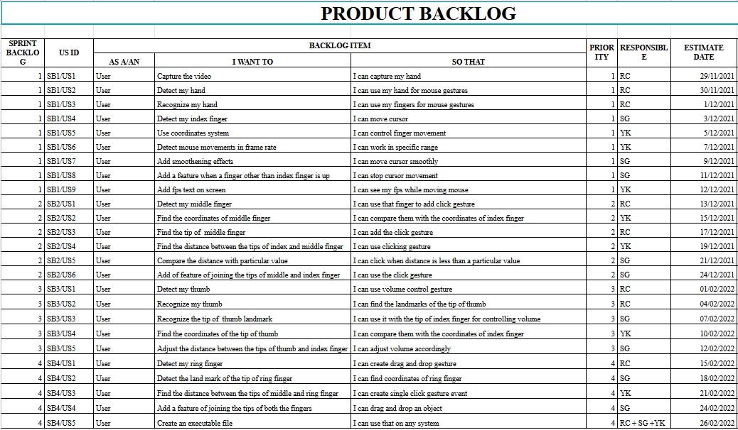

* 1. **Sprint Backlog-1**

Sprint Backlog is a collection of User stories and their associated tasks. This spring backlog consists of cursor moving functionality using our index finger.

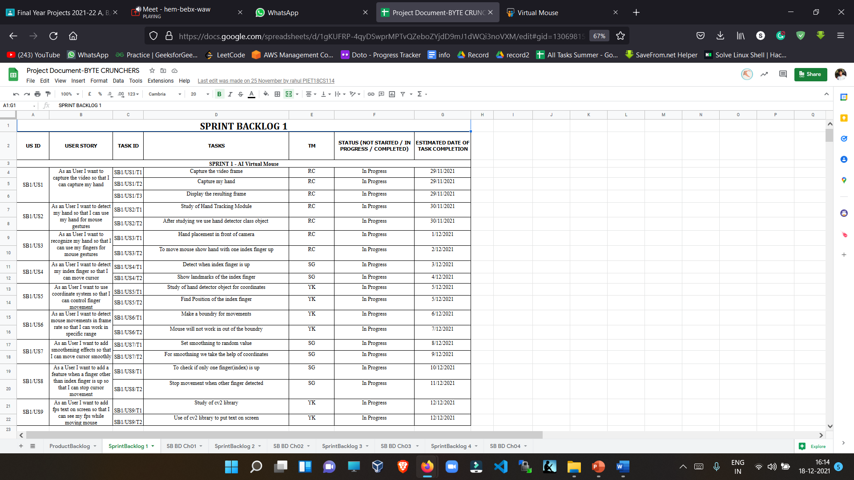

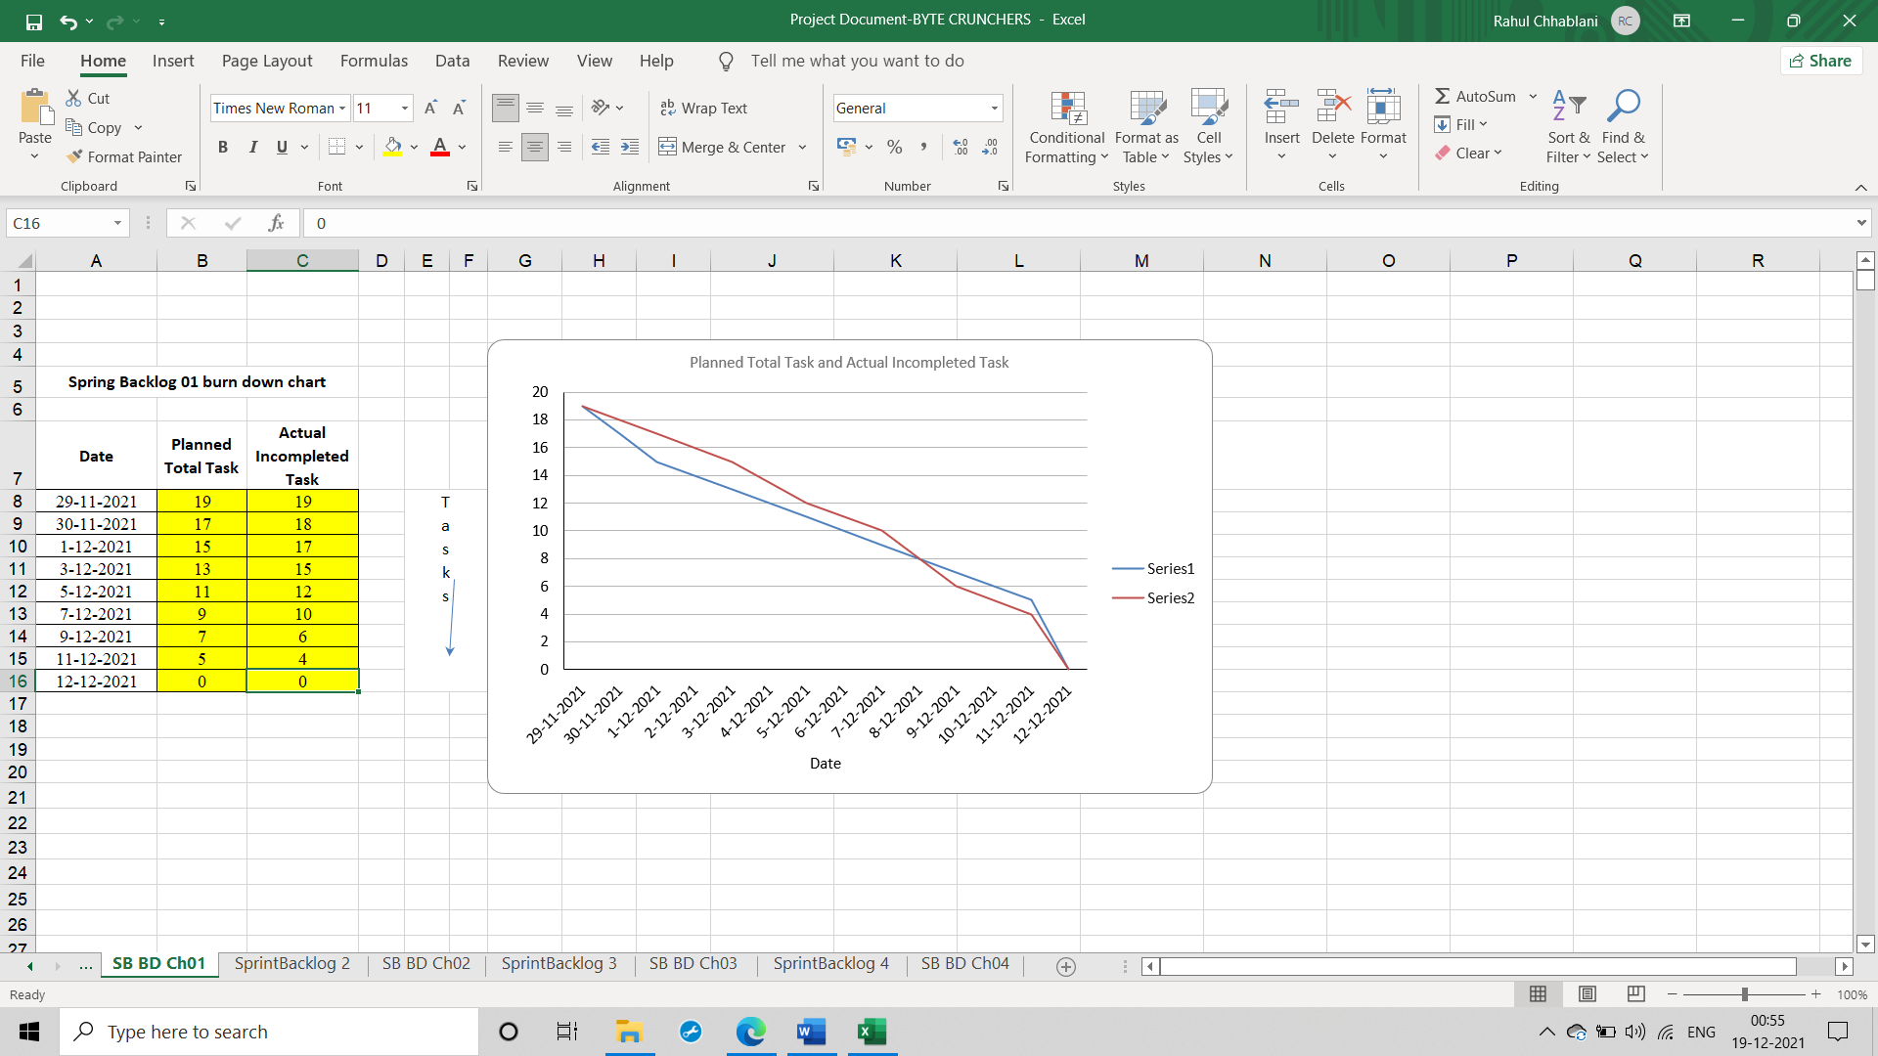

* 1. **Sprint Backlog-2**

This spring backlog consists of clicking functionality using our index finger and middle finger, as we join the tips of our index and middle finger, clicking functionality will be implemented.

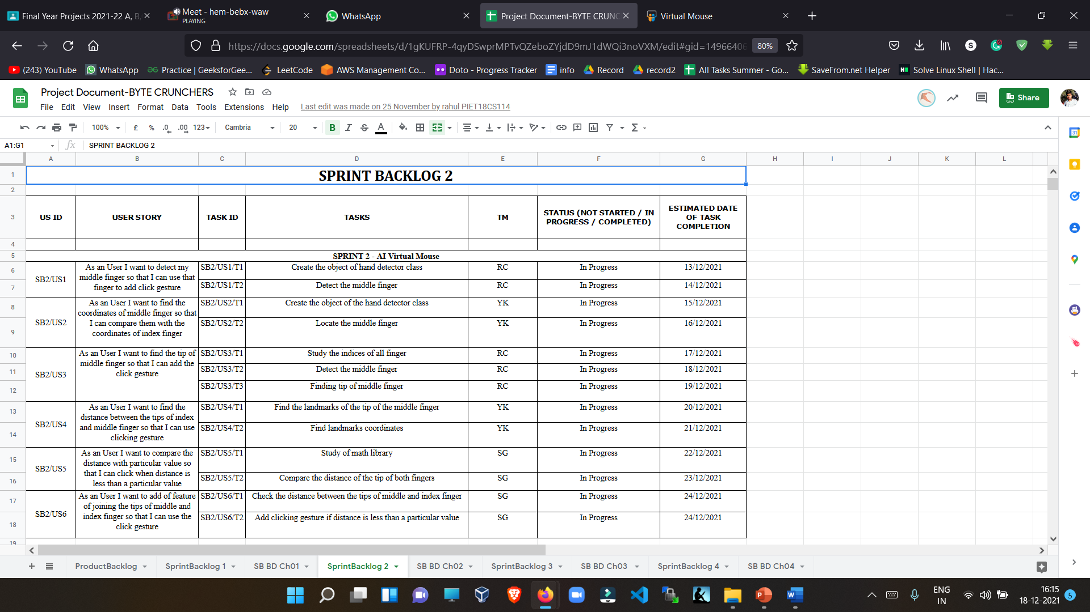

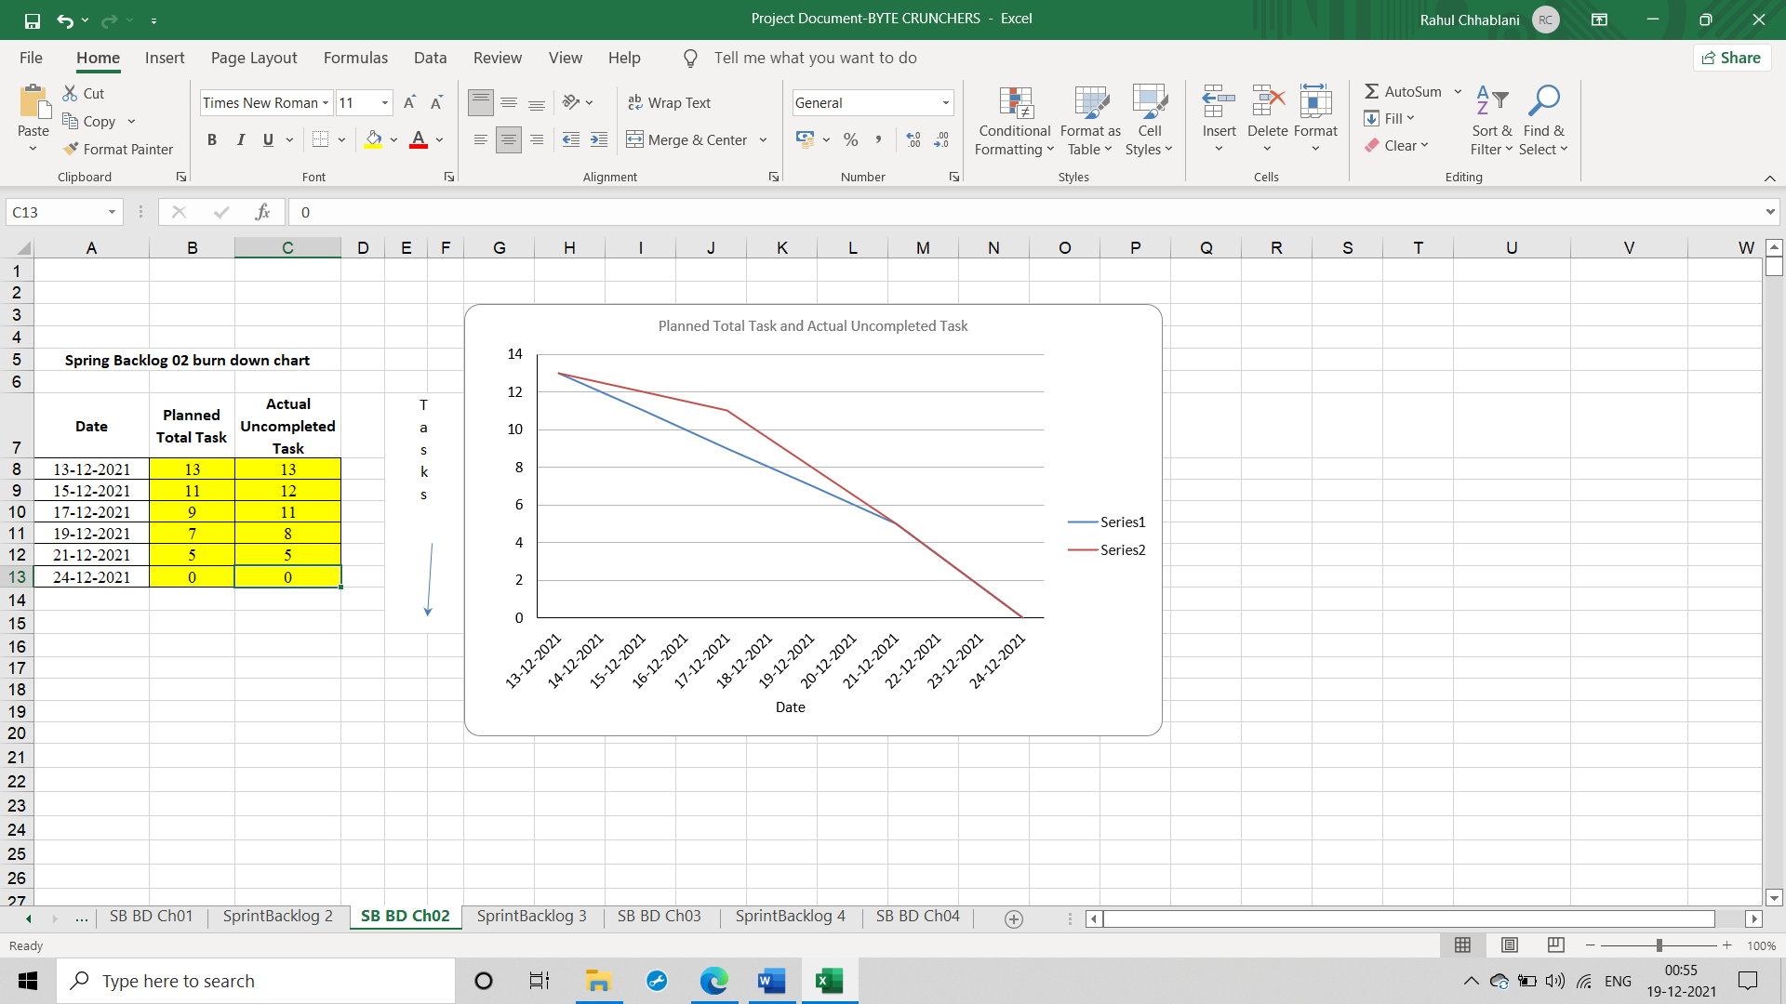

* 1. **Sprint Backlog-3**

This sprint backlog consists of volume control functionality using our index finger and thumb, as we increase the distance between the tips of the fingers, volume increases and volume decreases as we decrease the distance.

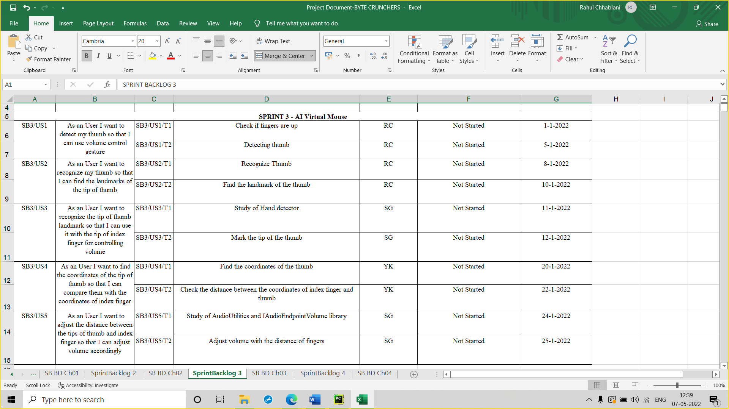

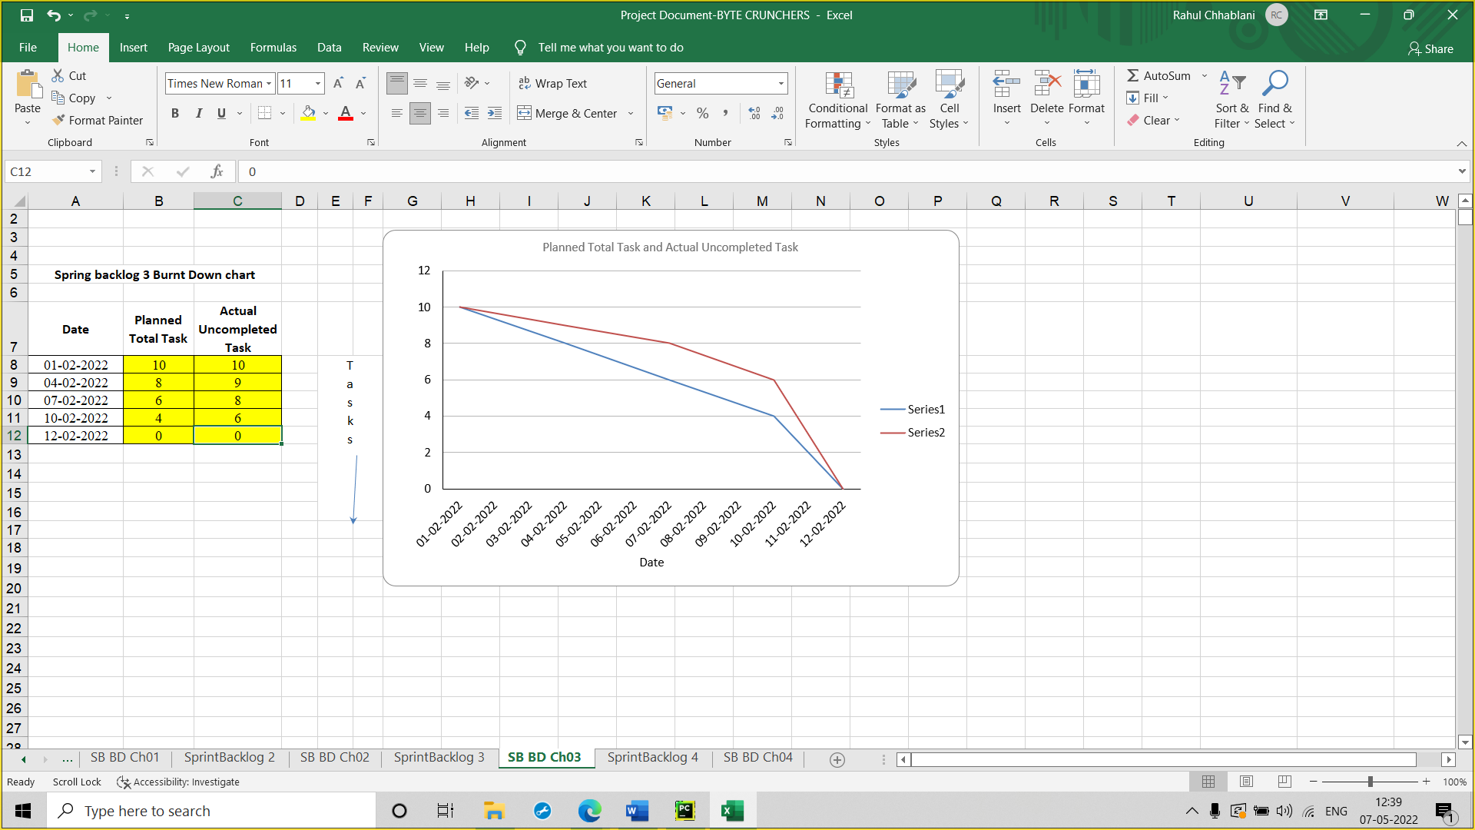

* 1. **Sprint Backlog-4**

This sprint backlog consists of scrolling functionality using our pinky finger and thumb, as we raise our pinky finger, page scrolls down and page scrolls up as we raise our thumb.

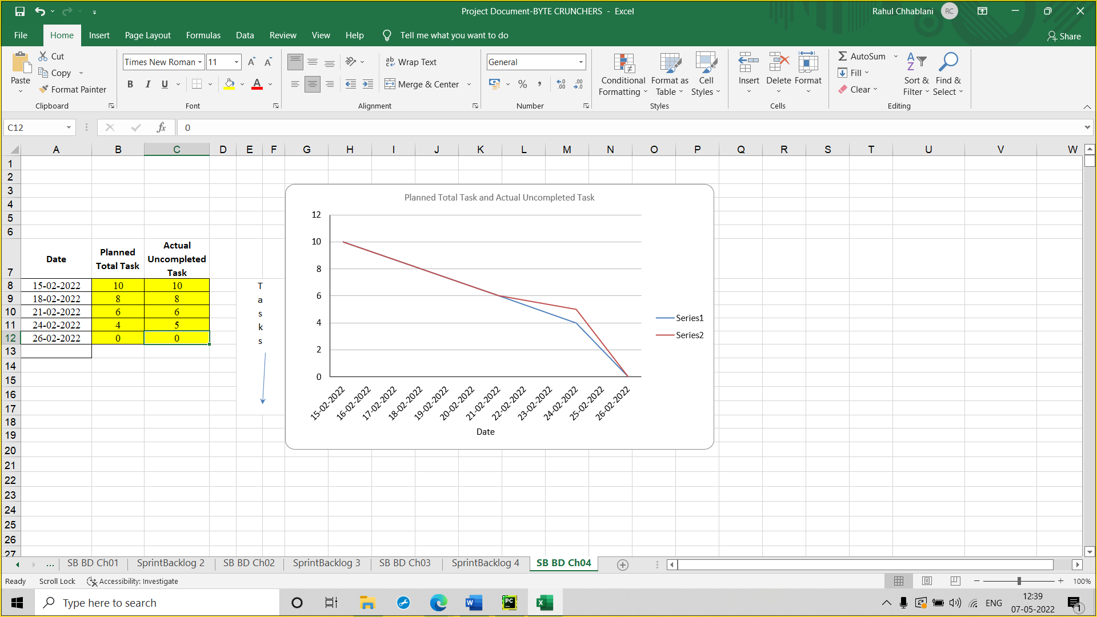

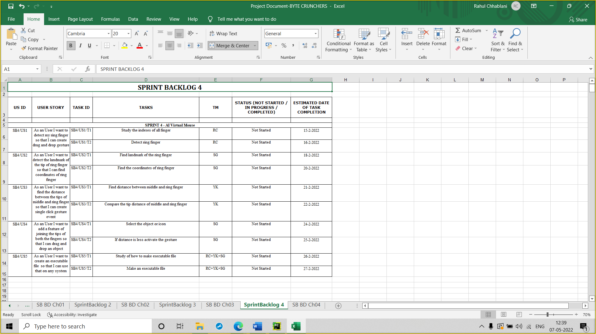

**CHAPTER 6**

**PROJECT IMPLEMENTAION**

**ARCHITECTURE**

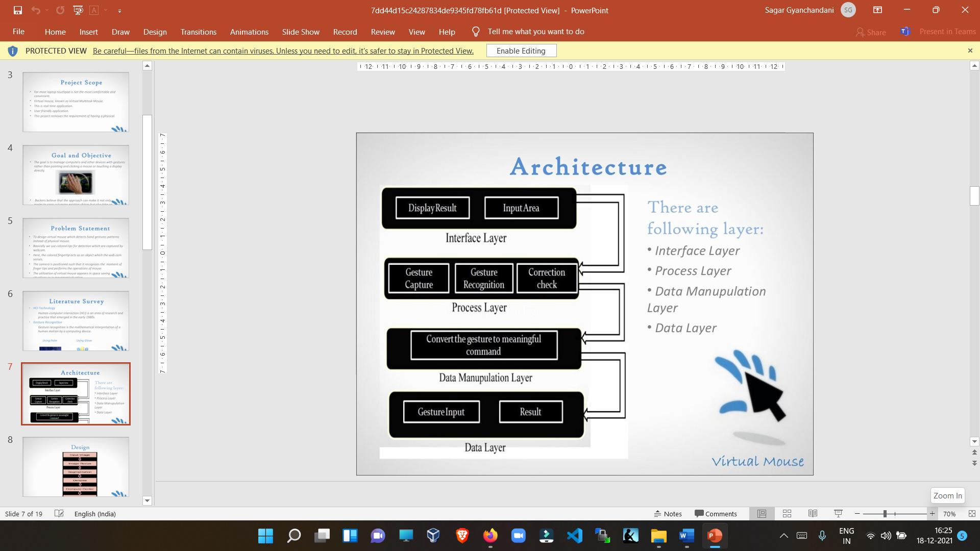

There are following layer:

* Interface Layer
* Process Layer
* Data Manipulation Layer
* Data Layer

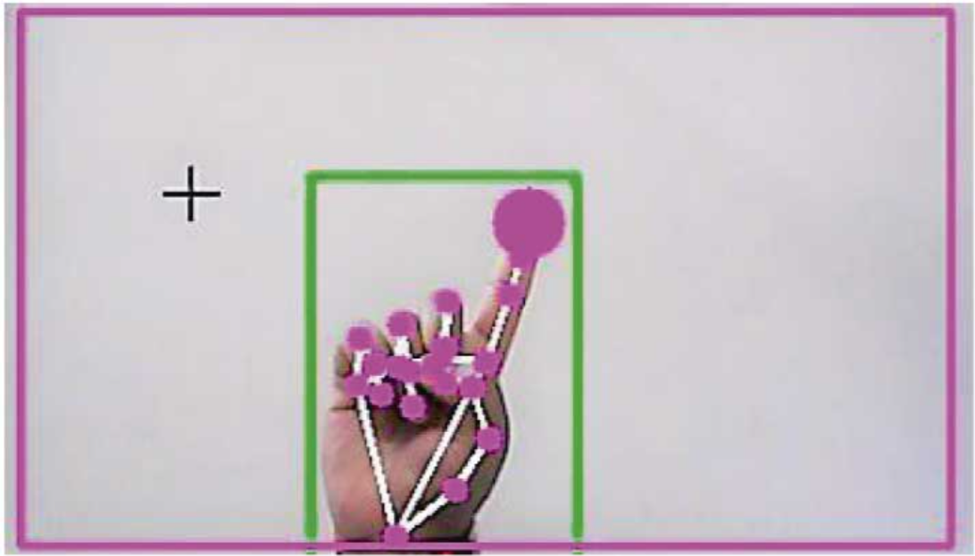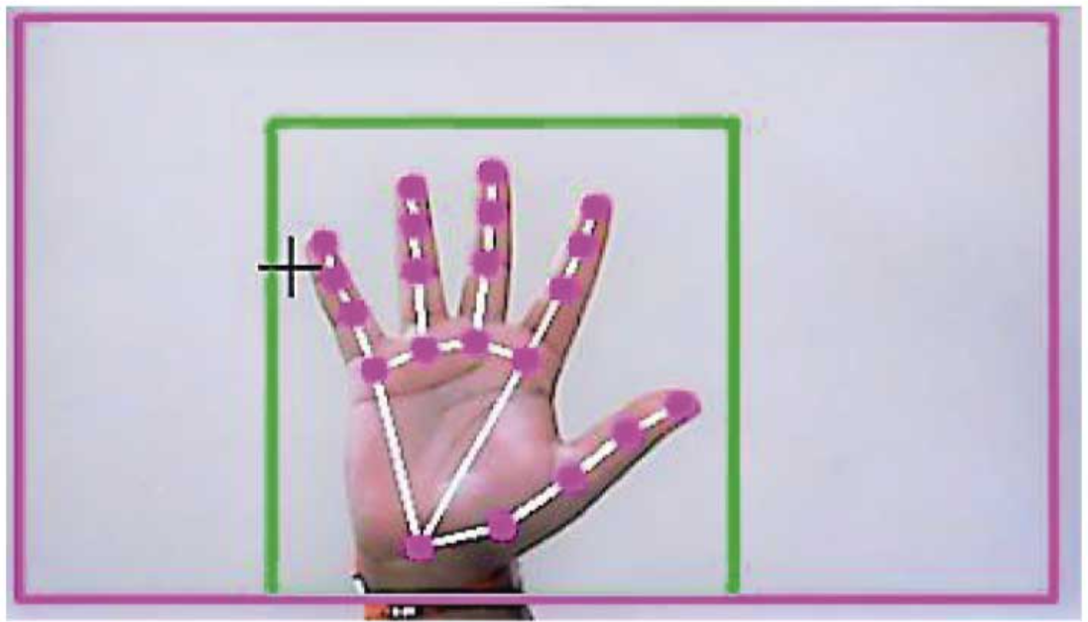

**Flow Chart**

Final Flow chart
Image
Acquisition
Object
Recognition
Trace Object
Coordinate
calculation
Setting Cursor
Position
Event
Ge...

**Screenshot**

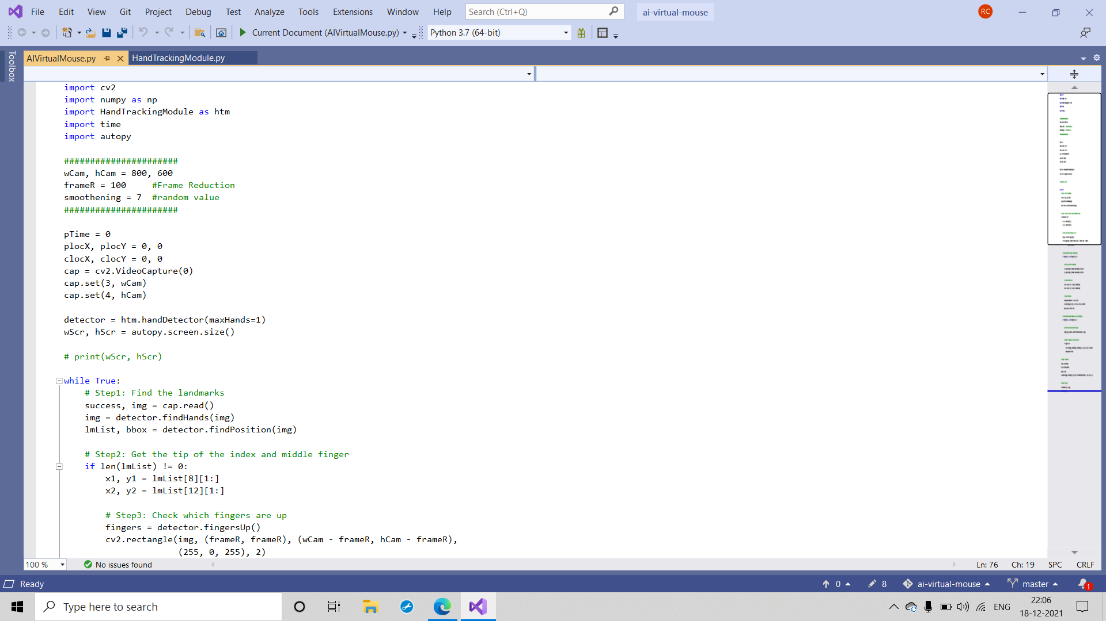

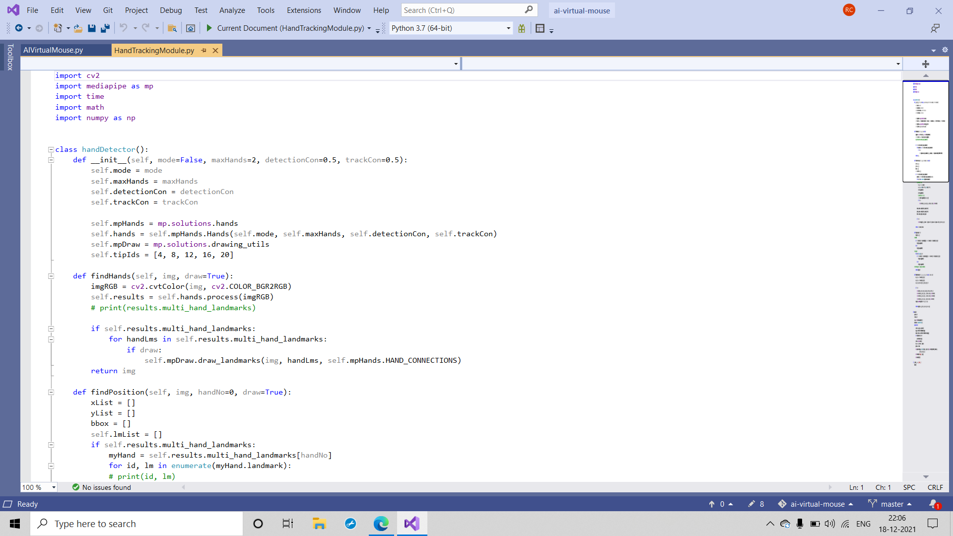

**CHAPTER 7**

**RESULTS**

**Conclusion**

* We are developing a system to control the mouse using a real-time camera.
* This system is based on computer vision algorithms and can do all mouse tasks.
* However, it is difficult to get stable results because of the variety of lighting and skin colors of human races.
* This system could be useful in presentations and to reduce work space.

**Future Scope**

The proposed AI virtual mouse has some flaws, such as a slight loss of accuracy when using the right click mouse function, and the model has some difficulties selecting text by clicking and dragging. These are some of the drawbacks of the proposed AI virtual mouse system, which will be addressed in future research.

Furthermore, the proposed method can be extended to handle virtual keyboard and mouse functionality, which is another future application of Human-Computer Interaction (HCI).

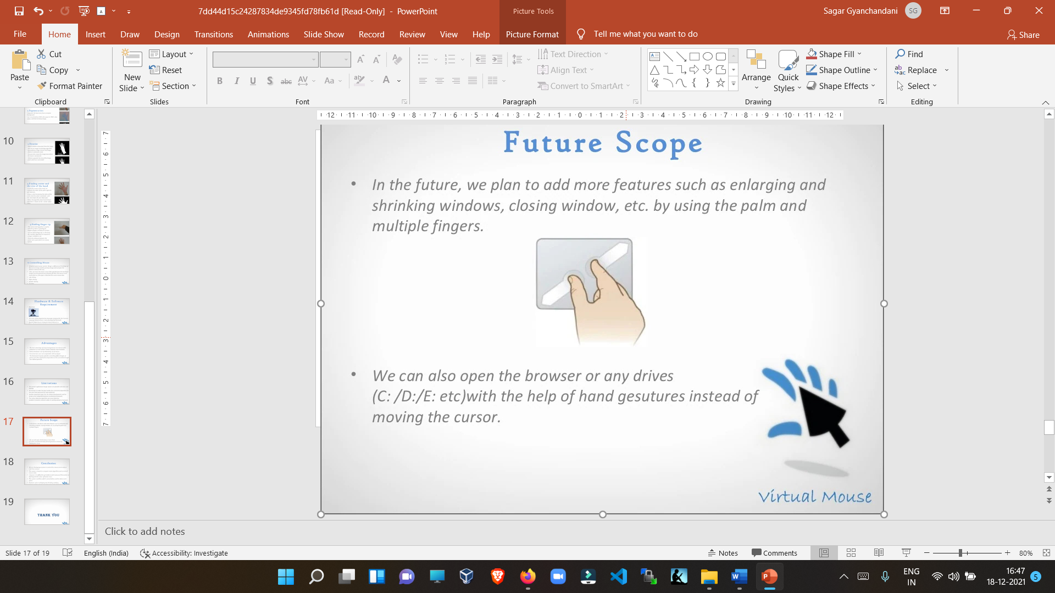

**REFERENCES**

* [**https://www.computervision.zone/**](https://www.computervision.zone/)
* [**https://www.slideshare.net/**](https://www.slideshare.net/)
* [**https://www.youtube.com/**](https://www.youtube.com/)